A PROJECT REPORT ON

“Neutraceutical”



submitted to Savitribai Phule Pune University

By

Khot Suyash Sanjay

**(SEAT NO- 7003)**

**Under the guidance of Asst. Prof. Pooja Shinde**

**Department of Pharmacology**



**NGSPMs College of Pharmacy, Anjaneri, Nashik, Maharashtra (2023-2024)**

# INDEX

|  |  |  |
| --- | --- | --- |
| **Sr. No** | **Contents** | **Page No.** |
| **1** | **ABSTRACT** | **3** |
| **2** | **INTRODUCTION** | **4** |
| **2.1** | **Historical Persepective** | **7** |
| **2.2** | **Regulatory Framework** | **8** |
| **2.3** | **Adverse Drug Monitoring** | **9** |
| **2.4** | **Neutraceuticals In Clinal Trials** | **10** |
| **2.5** | **Post Marketing Survellance** | **11** |
| **2.6** | **Challenges** | **12** |
| **2.7** | **Specific Aims** | **13** |
| **2.8** | **Detailed Info. Of Some Banned Drugs** | **15** |
| **3** | **ADR REPORTING FORM** | **17** |
| **4** | **LITERATURE REVIEW** | **19** |
| **5** | **PLAN OF WORK** | **25** |
| **6** | **FUTURE DIRECTION** | **26** |
| **7** | **CONCLUSION** | **27** |
| **8** | **REFERENCES** | **28** |

## Dr.Vijay.D.Wagh Asst. Prof. Pooja Shinde

**Principal Research Guide**

# ABSTRACT

Neutraceuticals, a diverse group of bioactive compounds derived from natural sources, have garnered increasing attention for their potential role in cancer treatment. This abstract provides a concise overview of the current state of research on the use of neutraceuticals in cancer therapy, highlighting their diverse mechanisms of action and the growing body of evidence supporting their efficacy.

Various neutraceuticals, including polyphenols, flavonoids, vitamins, and minerals, have demonstrated anti-cancer properties through modulation of key cellular processes such as apoptosis, inflammation, angiogenesis, and oxidative stress. Moreover, these compounds often exhibit low toxicity and minimal side effects compared to traditional cancer treatments, making them attractive candidates for integration into conventional therapeutic regimens.

Key sections of this abstract delve into the specific mechanisms by which neutraceuticals exert their anti-cancer effects, emphasizing the importance of targeting multiple pathways to enhance treatment efficacy. Additionally, the abstract explores the potential synergies between neutraceuticals and conventional cancer therapies, discussing emerging research on combination treatments that may enhance overall treatment outcomes.

The abstract also addresses challenges in the field, such as standardization of neutraceutical formulations, variability in individual responses, and the need for well-designed clinical trials to establish optimal dosage and treatment protocols. Insights from ongoing clinical studies are highlighted to underscore the translational potential of neutraceuticals from bench to bedside.

In conclusion, this abstract provides a comprehensive overview of the evolving landscape of neutraceuticals in cancer treatment, emphasizing the need for further research to unlock their full therapeutic potential. The promising results observed thus far suggest that neutraceuticals may play a pivotal role in the future of integrative cancer care, offering novel and complementary strategies to improve patient outcomes and enhance the overall quality of cancer treatment.

# INTRODUCTION

Cancer remains a formidable global health challenge, necessitating continuous exploration of innovative therapeutic strategies to enhance treatment efficacy and minimize adverse effects. In recent years, the spotlight has turned towards nutraceuticals—a diverse array of bioactive compounds derived from natural sources—as promising candidates in the fight against cancer. Unlike traditional pharmaceutical agents, nutraceuticals offer the advantage of being naturally occurring substances with demonstrated health benefits, often associated with their antioxidant, anti-inflammatory, and immunomodulatory properties.

The multifaceted nature of cancer, characterized by uncontrolled cell growth and the intricate interplay of various signaling pathways, has prompted researchers to seek alternative approaches to complement conventional treatments. Nutraceuticals, encompassing a wide range of substances such as polyphenols, flavonoids, vitamins, and minerals, have emerged as potential agents capable of modulating key cellular processes implicated in carcinogenesis. Their appeal lies not only in their biological activities but also in their generally favorable safety profiles, suggesting a potential role in reducing treatment-related toxicities.

This introduction provides a preliminary exploration into the landscape of nutraceuticals in cancer treatment, offering a glimpse into the diverse mechanisms by which these compounds exert their anti-cancer effects. As we delve deeper into the intricate molecular interactions and clinical implications of nutraceutical interventions, it becomes evident that these natural compounds hold promise as adjunctive therapies in the quest for more effective, personalized, and tolerable cancer treatments. However, amidst the optimism, it is crucial to acknowledge the challenges and gaps in knowledge that persist, necessitating further research and rigorous clinical investigation to fully harness the potential of nutraceuticals in the oncological realm.



## Terms commonly used in Neutraceutical use for Cancer treatment:

Antioxidants: Substances that inhibit oxidation and neutralize free radicals, potentially reducing oxidative stress and its associated damage to cells.

Polyphenols: A diverse group of natural compounds found in plants, known for their antioxidant properties and potential anti-cancer effects.

Flavonoids: A subclass of polyphenols with various health benefits, including anti-inflammatory and anti-cancer properties.

Apoptosis: Programmed cell death, a crucial process in preventing the survival and proliferation of abnormal cells, often targeted in cancer treatment.

Angiogenesis: The formation of new blood vessels, a process often dysregulated in cancer, and a target for certain anti-cancer strategies.

Immunomodulation: The ability to regulate or modify the immune response, a critical aspect in cancer treatment to enhance the body's ability to recognize and eliminate cancer cells.

Bioavailability: The extent and rate at which a substance, such as a nutraceutical, enters the bloodstream and reaches its target site within the body.

Inflammation: A biological response to harmful stimuli, often implicated in cancer development, and a target for anti-cancer nutraceuticals.

Phytochemicals: Bioactive compounds found in plants that may confer health benefits, with some exhibiting anti-cancer properties.

Cytotoxicity: The ability of a substance to cause cell death, a desirable trait in compounds targeting cancer cells.

Epigenetics: The study of changes in gene expression that do not involve alterations to the underlying DNA sequence, a field relevant to understanding how nutraceuticals may influence cancer development.

Clinical Trials: Rigorous research studies designed to evaluate the safety and efficacy of interventions, including nutraceuticals, in cancer patients.

# HISTORICAL PERSPECTIVE

Ancient Civilizations:

Traditional healing systems in ancient civilizations, such as Ayurveda in India and Traditional Chinese Medicine, incorporated a variety of plant-based remedies believed to promote overall health and combat diseases, including cancer.

Certain herbs and foods were recognized for their medicinal properties, and their use was documented in ancient texts.

Herbalism and Folk Medicine:

Throughout the Middle Ages and the Renaissance, herbalism played a significant role in folk medicine across cultures.

Plants and plant-derived substances were often used to alleviate symptoms and were believed to have therapeutic effects on various illnesses, including cancer.

Discovery of Specific Compounds:

The 19th and early 20th centuries witnessed the isolation and identification of specific bioactive compounds from plants. For example, the discovery of salicylic acid in willow bark laid the foundation for the development of aspirin.

Researchers began to explore the pharmacological properties of individual compounds found in plants.

Vitamins and Minerals:

The early 20th century saw the discovery of essential vitamins and minerals, leading to a better understanding of their role in health and disease.

Antioxidant vitamins like vitamin C and E garnered attention for their potential to protect cells from oxidative damage, a factor implicated in cancer development.

Mid-20th Century to Present:

The latter half of the 20th century and the early 21st century witnessed an increased focus on the potential health benefits of various dietary components.

Scientific research explored the anti-cancer properties of polyphenols, flavonoids, and other bioactive compounds found in fruits, vegetables, and herbs.

Epidemiological studies suggested associations between certain dietary patterns and cancer incidence.

# REGULATORY FRAMEWORK

Dietary Supplement Health and Education Act (DSHEA):

In the U.S., nutraceuticals, including dietary supplements, fall under the regulatory purview of the DSHEA. This act defines dietary supplements and outlines regulations related to their safety, labeling, and marketing. However, it places the burden on the FDA to prove that a dietary supplement is unsafe before taking regulatory action.

Federal Food, Drug, and Cosmetic Act (FD&C Act):

The FD&C Act governs the safety and labeling of food, drugs, and cosmetics, including dietary supplements. It grants the FDA authority to regulate and take action against products that pose health risks.

# New Dietary Ingredient (NDI) Notification:

# Manufacturers are required to notify the FDA if they intend to market a dietary supplement containing a new dietary ingredient that was not marketed in the U.S. before October 15, 1994.ADVERSE DRUG .

# MONITORING

Regulatory Oversight:

Adherence to Regulations: Regulatory agencies play a crucial role in ensuring that nutraceutical products comply with safety, efficacy, and labeling regulations. Continuous monitoring helps identify and address non-compliance issues.

Post-Market Surveillance: Regulatory bodies engage in post-market surveillance to monitor the safety and effectiveness of nutraceuticals once they are available to the public. Adverse event reporting systems are often in place to collect and analyze information on potential side effects.

Labeling and Claims: Monitoring the accuracy of product labeling and health claims is essential. Regulatory agencies assess whether claims made by nutraceuticals align with scientific evidence and do not mislead consumers, especially regarding cancer treatment.

Clinical Research and Trials:

Efficacy and Safety Studies: Continuous research is essential to evaluate the efficacy and safety of nutraceuticals in cancer treatment. Well-designed clinical trials provide valuable data to assess the impact of these compounds on cancer outcomes.

Combination Therapies: Research exploring the potential synergies between nutraceuticals and conventional cancer therapies is critical. Monitoring ongoing clinical trials and research publications helps assess the evolving landscape of combination treatments.

Healthcare Provider Education:

Professional Guidance: Healthcare providers should stay informed about the latest research and evidence-based recommendations regarding the use of nutraceuticals in cancer treatment. Continuous education helps ensure that providers can offer well-informed advice to patients.

Monitoring Patient Use: Healthcare providers play a crucial role in monitoring patients' use of nutraceuticals. This includes obtaining thorough medication histories, discussing potential interactions with conventional treatments, and monitoring for any adverse effects.

Public Awareness and Education:

Consumer Information: Public health campaigns and educational initiatives can inform consumers about the benefits and risks of nutraceuticals. C

# Actual Neutraceutical use for Cancer Treatment.

* + Pharmacovigilance in clinical trials is necessary for healthcare professionals and consumersto update the potential risk of medications. The drug company may facilitate post-marketingdrugsafety surveillance to observe the product's safety and effectiveness in the real world as it is not possible to predict all possible adverse effects of a drug based on pre-approval studies.
  + This crucial process involves systematic monitoring, data collection, analysis, and reportingof adverse events and safety related information throughout the various phases

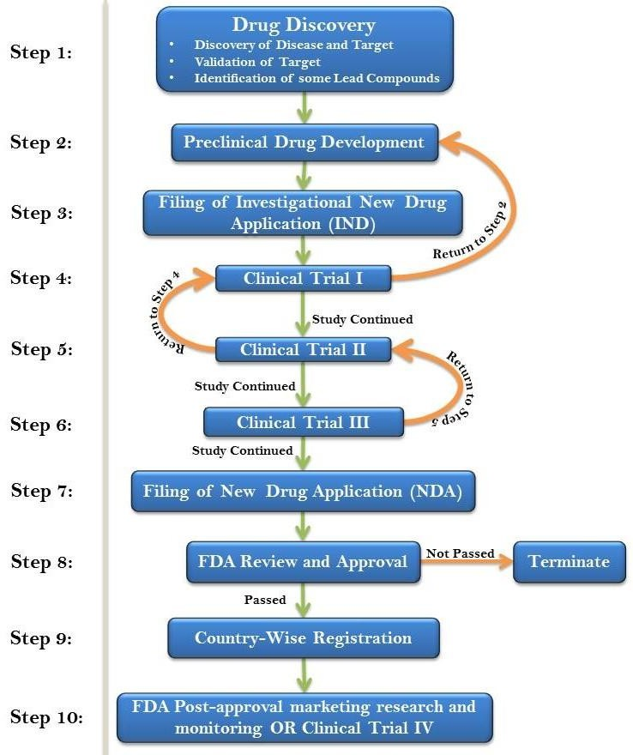

of clinical trials.

# POST-MARKETING SURVEILLANCE

* + Post-marketing surveillance, also known as post-market surveillance (PMS), is a critical phase in the life cycle of pharmaceutical and medical devices. It involves the ongoing monitoringof products once they are approved and available on the market. Here is some key informationabout post-marketing surveillance:
  + Purpose: - The primary purpose of post-marketing surveillance is to continue assessment thesafety and effectiveness of pharmaceuticals vaccines and medical device in real-world settings. It aims to identify and address any previously unrecognised adverse event, side effect or qualityissues that may not have been evident during clinical trials.
  + Data Sources: Data for post-marketing surveillance can come fromvarious sources, including :
    1. Pharmaceutical companies:
    2. Electronic health care:
    3. Clinical studies:

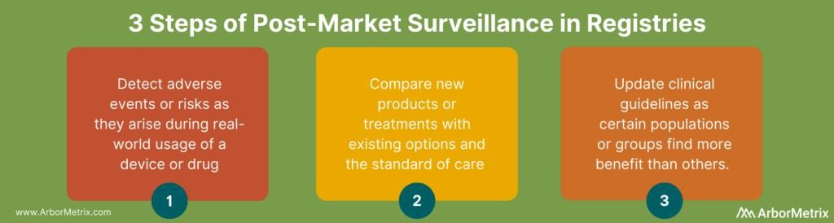

# CHALLENGES FOR PHARMCOVIGILLANCE ON DRUG SAFETY

# Limited Scientific Evidence:

# Many nutraceuticals lack extensive clinical evidence supporting their efficacy in cancer treatment. Robust, well-designed clinical trials are often scarce, leading to uncertainties about their effectiveness and appropriate usage.

# Heterogeneity of Nutraceuticals:

# Nutraceuticals encompass a wide range of compounds, each with its own distinct properties. This diversity makes it challenging to generalize findings, as different nutraceuticals may have varying effects on different types of cancer.

# Regulatory Variability:

# Regulations governing nutraceuticals vary across jurisdictions, leading to inconsistencies in product quality, safety, and efficacy standards. The lack of a harmonized global regulatory framework complicates the assessment and approval processes.

# Standardization Issues:

# Nutraceutical formulations can differ significantly between brands and even batches, leading to challenges in standardizing dosage, purity, and bioavailability. This variability can affect both efficacy and safety.

# Lack of Clear Guidelines:

# The absence of standardized guidelines for the use of nutraceuticals in cancer treatment contributes to uncertainty among healthcare professionals and patients. Clear dosing recommendations, indications, and contraindications are often lacking.

# Interaction with Conventional Treatments:

# Nutraceuticals may interact with conventional cancer treatments, affecting their efficacy or introducing potential side effects. Understanding these interactions and establishing safe combinations is a complex task, requiring thorough research.

# Patient Compliance and Expectations:

# Patient adherence to prescribed nutraceutical regimens can be challenging due to factors such as taste, inconvenience, or the need for long-term use. Unrealistic expectations regarding the effectiveness of nutraceuticals may also impact patient compliance.

# Ethical and Regulatory Issues:

# Ethical concerns may arise when patients opt for nutraceuticals as an alternative or complementary treatment without sufficient scientific evidence. Regulatory agencies face challenges in balancing consumer choice with the need for product safety and efficacy.

# Limited Funding for Research:

# Research on nutraceuticals often struggles to attract funding compared to pharmaceutical research. The lack of financial support limits the scale and quality of clinical trials, hindering the generation of robust evidence.

# Potential for Misinformation:

# The popularity of nutraceuticals has led to the dissemination of information through various channels, including social media. This can result in misinformation and the promotion of unproven treatments, potentially putting patients at risk.

# Biological Variability in Patient Response:

Individual responses to nutraceuticals can vary widely due to genetic, environmental, and lifestyle factors. Identifying predictive biomarkers for response remains a challenge, hindering personalized treatment approaches.

# Specific aims of Neutraceutical.

* + Maintain a robust monitoring system for new [safety](https://learning.eupati.eu/mod/glossary/showentry.php?eid=5&displayformat=dictionary) issues.
  + Implement effective approaches to minimize [risk](https://learning.eupati.eu/mod/glossary/showentry.php?eid=279&displayformat=dictionary).
  + Install procedures for rapid decision making and triggering actions in case of (immediate) [safety](https://learning.eupati.eu/mod/glossary/showentry.php?eid=5&displayformat=dictionary) concerns.
  + Improve patient care and [safety](https://learning.eupati.eu/mod/glossary/showentry.php?eid=5&displayformat=dictionary) in relation to the use of medicines and all medical and paramedical (services that support medical work, such as nursing, first aid, radiography) interventions
  + Improve public health and [safety](https://learning.eupati.eu/mod/glossary/showentry.php?eid=5&displayformat=dictionary) in relation to the use of medicines.
  + Contribute to the assessment of [benefit,](https://learning.eupati.eu/mod/glossary/showentry.php?eid=278&displayformat=dictionary) [risk,](https://learning.eupati.eu/mod/glossary/showentry.php?eid=279&displayformat=dictionary) and [effectiveness](https://learning.eupati.eu/mod/glossary/showentry.php?eid=161&displayformat=dictionary) (including cost- [effectiveness](https://learning.eupati.eu/mod/glossary/showentry.php?eid=161&displayformat=dictionary)) of medicines.
  + Secure the accessibility of information about the [safety](https://learning.eupati.eu/mod/glossary/showentry.php?eid=5&displayformat=dictionary) of medicinal products to patients, healthcare professionals and the public.
  + Promote understanding, education and training in [pharmacovigilance](https://learning.eupati.eu/mod/glossary/showentry.php?eid=80&displayformat=dictionary) and its effective communication to the public.

# Why is Neutraceutical important?

## Patient safety and continuous vigilance

By definition, drug safety ensures that a patient’s safety and wellbeing is safeguarded throughout the entire drug development lifecycle, including when the drug is readily available on the market. Indeed, drugs are continuously monitored for other side effects on patients, and any new data is collected and reported to health authorities on a regular basis. While other areas focus on improving patient lives in everything that they do, no other department has such a sharp focus on patient safety as an end-point.

## Power and authority

This continuous vigilance does mean that, alongside others in the business, senior leaders within a drug safety team have the responsibility and authority to recommend that a development process is stopped, or that an approved drug is pulled from the market. EU QPPVs are especially important in this process, and again this goes to demonstrate the importance and central role of drug safety.

## Keeping it moving

In many ways, drug safety helps to keep the wheels of a pharmaceutical company moving. The nature of drug safety means that it works on a very cross-functional basis. Therefore, the influence and value which the division can add to other aspects of the business is tremendous.

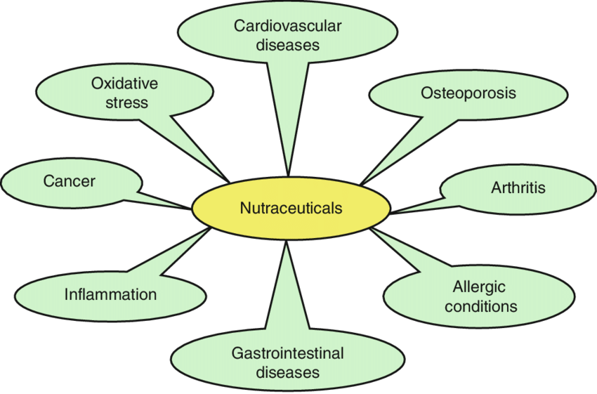

# Detailed information of Some banned drugs



|  |  |  |
| --- | --- | --- |
| DRUGS | NAME USE | REASON TO BAN |
| Analgin | Pain-killer | Bone-marrow depression. |
| Cisapride | Acidity, constipation | Irregular heart beat. |
| Droperidol | Anti-depressant | Irregular heart beat. |
| Nimesulide | Pain-killer, fever | Liver failure. |
| Nitrofurazon | Antibacterial Cream | Cancer . |
| Phenolphtalein | Laxative | Cancer. |
| Phenylpropanamine | Cold and Cough | Stroke. |
| Oxyphenbutazone | NSAID | Bone marrow depressions. |
| Piperazine | Anti-worms | Nerve damage. |

**Flow chart of process of banning drugs**

Executive committee examines harmful effects of the drug.

The results are reported to the drugs technical advisory board.

The government issues the ban order.

DCGI notifies all state drug authorities.

DCGI notifies all state drug authoriti

**LITERATURE REVIEW**

1. Introduction:

Nutraceuticals, a diverse group of bioactive compounds derived from natural sources, have gained attention for their potential role in cancer treatment. This review explores the current state of knowledge regarding the efficacy, mechanisms of action, and challenges associated with nutraceutical use in the context of cancer therapy.

2. Classification of Nutraceuticals:

Categorization of nutraceuticals based on chemical classes, including polyphenols (e.g., resveratrol, curcumin), flavonoids, vitamins (e.g., vitamin D), minerals (e.g., selenium), and omega-3 fatty acids. Each class is explored for its anti-cancer properties and potential mechanisms of action.

3. Mechanisms of Action:

In-depth examination of the molecular and cellular mechanisms by which nutraceuticals exert anti-cancer effects. This includes modulation of apoptosis, inhibition of angiogenesis, anti-inflammatory properties, and interference with key signaling pathways implicated in cancer progression.

4. Clinical Evidence:

Review of clinical trials investigating the effectiveness of nutraceuticals in cancer treatment. Summarization of findings, patient outcomes, and methodological considerations. Discussion on the challenges of conducting clinical trials with nutraceuticals, including issues related to study design, patient selection, and endpoints.

5. Synergies with Conventional Therapies:

Exploration of the potential synergistic effects of combining nutraceuticals with conventional cancer treatments such as chemotherapy, radiation, and immunotherapy. Evaluation of studies assessing enhanced treatment outcomes, reduced side effects, and improved quality of life in cancer patients.

6. Safety and Toxicity:

Analysis of safety profiles and potential toxicities associated with long-term nutraceutical use. Discussion on factors influencing safety, including dosage, formulation, and interactions with other medications. Consideration of the importance of standardized production and quality control.

7. Regulatory Landscape:

Overview of regulatory frameworks governing nutraceuticals in different regions. Discussion on the challenges of regulating these compounds, including issues related to standardization, labeling, and the classification of nutraceuticals as food, dietary supplements, or drugs.

8. Patient Perspectives and Compliance:

Examination of patient attitudes towards nutraceuticals, factors influencing their choice to incorporate these compounds into their cancer treatment, and challenges related to compliance. Discussion on the role of healthcare providers in guiding patients and ensuring informed decision-making.

9. Future Directions and Challenges:

Identification of gaps in current knowledge and areas requiring further research. Exploration of emerging trends in nutraceutical research, including the development of novel formulations, personalized approaches based on patient characteristics, and innovative study designs.

10. Conclusion:

Summarization of key findings, highlighting the potential benefits of nutraceuticals in cancer treatment, while acknowledging the existing challenges and the need for continued research, standardization, and regulatory clarity.

This broad outline can serve as a starting point for a more in-depth literature review on the topic. Ensure to refer to the latest literature to capture the most recent developments in this rapidly evolving field.

11. Epidemiological Studies:

Examination of population-based studies investigating the associations between dietary patterns rich in nutraceuticals and cancer incidence. Consideration of diverse populations, lifestyle factors, and geographical variations.

12. Preclinical Studies and In Vitro Models:

In-depth analysis of preclinical studies, including cell culture and animal models, elucidating the mechanisms and potential efficacy of nutraceuticals in preventing or treating cancer. Discussion on the translational relevance of findings to human clinical trials.

13. Challenges in Nutraceutical Bioavailability:

Exploration of challenges related to the bioavailability of nutraceutical compounds, considering factors such as absorption, metabolism, and tissue distribution. Discussion on strategies to enhance bioavailability for improved therapeutic outcomes.

14. Hormone-Related Cancers and Nutraceuticals:

Specific focus on nutraceuticals and their impact on hormone-related cancers, such as breast and prostate cancer. Examination of compounds with potential hormone-modulating effects and their implications for cancer prevention and treatment.

15. Impact on Cancer Metabolism:

Review of literature exploring how nutraceuticals influence cancer metabolism, including effects on glucose metabolism, lipid synthesis, and mitochondrial function. Consideration of potential implications for targeted cancer therapies.

16. Gut Microbiota and Nutraceuticals:

Investigation into the interplay between nutraceuticals and the gut microbiota. Exploration of studies highlighting how these compounds may modulate the gut microbiome, potentially influencing cancer development and treatment responses.

17. Challenges in Study Design:

Critical analysis of challenges in designing nutraceutical-focused cancer studies, including the need for standardized protocols, appropriate control groups, and consideration of confounding variables. Discussion on strategies to address these challenges.

18. Emerging Nutraceuticals:

Exploration of novel nutraceutical compounds or formulations that have recently gained attention in cancer research. Evaluation of early-stage studies and their potential implications for future therapeutic developments.

19. Patient-Centered Outcomes:

Examination of studies assessing patient-reported outcomes, quality of life, and psychosocial aspects related to the incorporation of nutraceuticals into cancer treatment. Discussion on the importance of holistic patient care.

20. Ethical Considerations in Nutraceutical Research:

Analysis of ethical considerations associated with nutraceutical research in cancer treatment, including informed consent, disclosure of potential risks and benefits, and the responsible communication of findings to patients and the public.

This expanded literature review aims to cover a broader spectrum of topics related to nutraceutical use in cancer treatment. Each point can be further developed with a detailed examination of relevant studies, findings, and the current state of knowledge in the respective areas.

# PLAN OF WORK

1. Defining the Scope and Objectives:

Clearly define the scope of your literature review, specifying the types of nutraceuticals and cancers you aim to cover. Outline the objectives, such as summarizing current evidence, identifying gaps, and exploring future research directions.

2. Conducting a Preliminary Literature Search:

Begin with a preliminary literature search to identify key articles, reviews, and systematic reviews on the topic. This helps you gauge the existing literature and refine your research questions.

3. Developing Research Questions:

Based on the preliminary review, articulate specific research questions that your literature review will address. These questions should guide your subsequent search and synthesis of information.

4. Creating a Conceptual Framework:

Develop a conceptual framework to organize your literature review. This may involve categorizing nutraceuticals based on types (polyphenols, vitamins, etc.), mechanisms of action, cancer types, and other relevant dimensions.

5. Defining Search Terms and Criteria:

Identify relevant keywords, phrases, and controlled vocabulary terms to use in your literature search. Establish inclusion and exclusion criteria to ensure the selection of high-quality studies meeting your research objectives.

6. Systematic Literature Search:

Conduct a systematic literature search using academic databases such as PubMed, Scopus, and Web of Science. Employ your defined search terms and criteria to retrieve relevant articles. Keep a record of your search strategy for transparency.

7. Screening and Selecting Studies:

Screen the search results based on title and abstract to identify potentially relevant studies. Apply your inclusion and exclusion criteria to select studies for full-text review. Utilize bibliographic management software for efficient organization.

8. Full-Text Review and Data Extraction:

Conduct a detailed review of the full texts of selected articles. Extract relevant data, including study design, participant characteristics, nutraceutical interventions, outcomes, and key findings. Develop a structured data extraction form for consistency.

9. Synthesize Findings:

Synthesize the findings from individual studies to address your research questions. Organize the information based on your conceptual framework, highlighting patterns, contradictions, and areas requiring further exploration.

10. Address Different Aspects:

Dedicate sections of your literature review to different aspects, such as the classification of nutraceuticals, mechanisms of action, clinical evidence, safety considerations, and challenges. This helps create a structured and comprehensive narrative.

11. Critical Appraisal:

Critically appraise the methodological quality of the studies included in your review. Assess the risk of bias, study design limitations, and the generalizability of findings. Consider using established tools for critical appraisal.

12. Identify Gaps and Future Directions:

Reflect on the literature to identify gaps in knowledge and areas requiring further investigation. Discuss potential future research directions and the implications of current findings for clinical practice.

13. Draft and Revise:

Draft your literature review, ensuring a logical flow and clear organization. Revise the draft iteratively, paying attention to the clarity of writing, coherence of arguments, and adherence to the defined scope and objectives.

14. Citation Management:

Manage your citations using citation management software such as EndNote, Zotero, or Mendeley. Ensure accurate and consistent citation throughout your literature review.

15. Finalize and Submit:

Finalize your literature review, incorporating feedback from peers or mentors. Ensure proper formatting and citation according to your chosen style guide. Submit your literature review for publication or academic assessment.

# FUTURE DIRECTION

* + In the future, pharmacovigilance will focus on improving drug safety through enhancedsurveillance and risk management strategies. We'll see advancements in technologyanddata analysis to better detect and assess adverse drug reactions. The goal is to ensurethesafety and well-being of patients.
  + pharmacovigilance will continue to evolve to ensure drug safety. Advanced technologieslike artificial intelligence and machine learning will be used for better data analysis anddetection of adverse drug reactions. There will be a greater emphasis on proactivemonitoring and effective risk management strategies. This will ultimately lead to improvedpatient safety and better public health outcomes.

CONSIDERATIONS FOR THE FUTURE AND ITS CHALLENGES:

1. Pharmacovigilance should be less focused on finding harm and more on extending knowledgeofsafety.
2. Complex risk-benefit decisions are amenable to, and likely to be improved by, the use of formal decision analysis.
3. Pharmacovigilance should operate in a culture of scientific development. This requires the right balance of inputs from various disciplines, a stronger academic base, and greater availability of basic training, and resource which i to scientific strategy.

# CONCLUSION

* + Review articles on pharmacovigilance and drug safety play a crucial role in summarizingand synthesizing existing knowledge in this field. They provide valuable insights intothemonitoring, assessment, and management of adverse drug reactions, ultimately contributingto safer and more effective healthcare practices. These articles serve as important resourcesfor healthcare professionals, researchers, and policymakers to enhance drug safetyandpatient care. However, it is essential to recognize that the landscape of pharmacovigilanceisdynamic, with ongoing developments and challenges, necessitating continuous updates andimprovements in drug safety practices.
  + Pharmacovigilance continues to play a cru- cial role in meeting the challenges posedbytheever increasing range and potency of medicines, all of which carry an inevitable andsometimes unpredictable potential for harm. When adverse effects and toxicity doappear, especially when previously un- known, it is essential that these are reported, analyzedandtheir significance is communi- cated effectively to the audience having knowledgetointerpret the information. For all medicines, there is a trade-off between the benefits andthepotential for harm. The harm can be minimized by ensuring that medicines of goodquality, safety and efficacy are us¹ rationally, and that the expectations and co cerns of the patient are taken into account Back when therapeutic decisions are made.

# REFERENCES

1. Montastruc JL, Bondon-Guitton E, Abadie D, Lacroix I, Berreni A, Pugnet G, Durrieu G, Sailler L, Giroud JP, Damase-Michel C, Montastruc F. Pharmacovigilance, risks and adverse effects of self-medication. Therapie. 2016 Apr;71(2):257-62. English, French. doi: 10.1016/j.therap.2016.02.012. Epub 2016 Feb 6. PMID: 27080848.
2. Berreni A, Montastruc F, Bondon-Guitton E, Rousseau V, Abadie D, Durrieu G, Chebane L, Giroud JP, Bagheri H, Montastruc JL. Adverse drug reactions to self- medication: a study in a pharmacovigilance database. Fundam Clin Pharmacol. 2015 Oct;29(5):517-20. doi: 10.1111/fcp.12140. Epub 2015 Aug 24. PMID: 26215671.
3. Montastruc JL, Bagheri H, Geraud T, Lapeyre-Mestre M. Pharmacovigilance de l'automédication [Pharmacovigilance of self-medication]. Therapie. 1997 Mar- Apr;52(2):105-10. French. PMID: 9231503.
4. Bagheri H, Frelezeau F, Montastruc JL. Effets indésirables des médicaments administrés par voie locale [Adverse effects of locally applied drugs]. Therapie. 2000 Jan-Feb;55(1):211-9. French. PMID: 10860026.
5. Brefel-Courbon C, Gardette V, Ory F, Montastruc JL. Drug-induced myoclonus: a French pharmacovigilance database study. Neurophysiol Clin. 2006 Sep-Dec;36(5- 6):333-6. doi: 10.1016/j.neucli.2006.12.003. Epub 2007 Jan 25. PMID: 17336778.New strategies for drug monitoring. BMJ 1977; 1: 861-2
6. Durrieu G, Olivier P, Bagheri H, Montastruc JL; French Network of Pharmacovigilance Centers. Overview of adverse reactions to nefopam: an analysis of the French Pharmacovigilance database. Fundam Clin Pharmacol. 2007 Oct;21(5):555-8. doi: 10.1111/j.1472-8206.2007.00499.x. PMID: 17868209.
7. Pillans PI, Woods DJ. Adverse reactions associated with nefopam. N Z Med J. 1995 Sep 22;108(1008):382-4. PMID: 7566787.
8. Calmi D, Pagnoni B, Tiengo M, Ravanelli A, Savio G, Dal Prà ML. Nefopam in postoperative pain. Arzneimittelforschung. 1985;35(6):981-3. PMID: 3927931.
9. Schietzel M. Analgesie mit geringen Nebenwirkungen [Analgesia with mild side effects]. Fortschr Med. 1977 Dec 1;95(45):2743-6. German. PMID: 336498.Rawlins MD. Spontaneous reporting of adverse drug reactions. Br J Clin Pharmacol 1988; 26: 1–11
10. Kakkar M, Derry S, Moore RA, McQuay HJ. Single dose oral nefopam for acute postoperative pain in adults. Cochrane Database Syst Rev. 2009Jul8;2009(3):CD007442. doi: 10.1002/14651858.CD007442.pub2. PMID: 19588431; PMCID: PMC4170989.Mann RD. Drug safety alerts — a review of ‘current problems’. Pharmacoepidemiol Drug Saf 1992; 1: 269–79
11. Moore RA, Wiffen PJ, Derry S, Maguire T, Roy YM, Tyrrell L. Non-prescription (OTC) oral analgesics for acute pain - an overview of Cochrane reviews. Cochrane Database Syst Rev. 2015 Nov 4;2015(11):CD010794. doi:

10.1002/14651858.CD010794.pub2. PMID: 26544675; PMCID: PMC6485506.XIII

Journées Françaises de Pharmacovigilance. Therapie 1992; 47 (5): 359-453

1. Olsson S. The role of the WHO Programme on international drug monitoring in coordinating worldwide drug safety efforts. Drug Saf. 1998;19:1–10
2. Lazarou J, Pomeranz BH, Corey P. Incidence of adverse drug reactions in hospitalized patients: a meta-analysis of prospective studies. JAMA. 1998;279:1200–1205
3. Biswas, Pipasha, and Arun K. Biswas. "Setting standards for proactive pharmacovigilance in India: The way forward." *Indian journal of pharmacology* 39, no. 3 (2007): 124.
4. Härmark L, van Grootheest AC. Pharmacovigilance: methods, recent developments and future perspectives. Eur J Clin Pharmacol. 2008 Aug;64(8):743-52. doi: 10.1007/s00228-008-0475-9. Epub 2008 Jun 4. PMID: 18523760.
5. van Grootheest K, Olsson S, Couper M, de Jong-van den Berg L. Pharmacists' role in reporting adverse drug reactions in an international perspective. Pharmacoepidemiol Drug Saf. 2004 Jul;13(7):457-64. doi: 10.1002/pds.897. PMID: 15269929.
6. White TJ, Arakelian A, Rho JP. Counting the costs of drug-related adverse events. *Pharmacoeconomics.* 1999;15:445–58. [[PubMed](https://pubmed.ncbi.nlm.nih.gov/10537962)]
7. Avorn J, Solomon DH. Cultural and economic factors that (mis)shape antibiotic use: The nonpharmacologic basis of therapeutics. *Ann Intern Med.* 2000;133:128–35.
8. Waller PC, Evans SJ. A model for the future conduct of pharmacovigilance. Pharmacoepidemiol Drug Saf. 2003 Jan-Feb;12(1):17-29. doi: 10.1002/pds.773. PMID: 12616844.
9. Ball LK, Evans G, Bostrom A. Risky business: Challenges in vaccine risk communication. *Pediatrics.* 1998;101:453–8. [[PubMed](https://pubmed.ncbi.nlm.nih.gov/9481013)] [[Google Scholar](https://scholar.google.com/scholar_lookup?journal=Pediatrics&title=Risky%2Bbusiness%3A%2BChallenges%2Bin%2Bvaccine%2Brisk%2Bcommunication&author=LK%2BBall&author=G%2BEvans&author=A%2BBostrom&volume=101&publication_year=1998&pages=453-8&pmid=9481013)]
10. . Bapna JS, Tripathi CD, Tekur U. Drug utilization patterns in the third world. *Pharmacoeconomics.* 1996;9:286–94. [[PubMed](https://pubmed.ncbi.nlm.nih.gov/10160103)] [[Google Scholar](https://scholar.google.com/scholar_lookup?journal=Pharmacoeconomics&title=Drug%2Butilization%2Bpatterns%2Bin%2Bthe%2Bthird%2Bworld&author=JS%2BBapna&author=CD%2BTripathi&author=U%2BTekur&volume=9&publication_year=1996&pages=286-94&pmid=10160103)]
11. Sleath B, Svarstad B, Roter D. Physician motivation for non-scientific drug prescribing. *Soc Sci Med.* 1997;44:541–8.
12. Vaccine safety. Vaccine Safety Advisory Committee. *Wkly Epidemiol Rec.* 1999;74:337–40.
13. Ioannidis JP, Lau J. Completeness of safety reporting in randomized trials: An evaluation of 7 medical areas. *JAMA.* 2001;285:437–43.
14. Waller PC, Wood SM, Langman MJ, Breckenridge AM, Rawlins MD. Review of company postmarketing surveillance studies. *BMJ.* 1992;304:1470–2.
15. 4th Annual Meeting of the European Society of Pharmacovigilance (ESOP): 1996 Sep 18–20; Lisbon
16. Fucik H, Edwards IR. Impact and credibility of the WHO adverse reaction signals. Drug Inform J 1996; 30: 461–4
17. World Health Organization . Safety of medicines. A guide to detecting and reporting adverse drug reactions– why health professionals need to take action. Geneva: World Health Organization; 2002.
18. World Health Organization. Safety monitoring of medicinal products: guidelines for setting up and running a pharmacovigilance centre. Uppsala: Uppsala Monitoring Centre, World Health Organization; 2000.
19. Routledge P. 150 years of pharmacovigilance. Lancet. 1998;351:1200–1201. 5. van Grootheest K. The dawn of pharmacovigilance. Intern J Pharm Med. 2003;17:195– 200.
20. Folb PI, ten Ham M. Drug monitoring in developing countries: A drug regulator’s perspective. *Drug Inf J.* 1995;29:303–5. [[Google Scholar](https://scholar.google.com/scholar_lookup?journal=Drug%2BInf%2BJ&title=Drug%2Bmonitoring%2Bin%2Bdeveloping%2Bcountries%3A%2BA%2Bdrug%2Bregulator%E2%80%99s%2Bperspective&author=PI%2BFolb&author=M%2Bten%2BHam&volume=29&publication_year=1995&pages=303-5)]
21. Talbot JC, Nilsson BS. Pharmacovigilance in the pharmaceutical industry. *Br J Clin Pharmacol.* 1998;45:427–31.
22. Moore N. The role of the clinical pharmacologist in the management of ADRs. *Drug Saf.* 2001;24:1–7.
23. Rich ML. Fatal case of aplastic anaemia following chloramphenicol therapy. Ann Intern Med. 1950;33:1459–1459.
24. Coulter DM. The New Zealand intensive medicines monitoring programme in proactive safety surveillance. *Pharmacoepidemiol Drug Saf.* 2000;9:273–

80. [[PubMed](https://pubmed.ncbi.nlm.nih.gov/19025828)]

1. Mackay FJ. Post-marketing studies: The work of the drug safety research unit. *Drug Saf.* 1998;19:343–53. [[PubMed](https://pubmed.ncbi.nlm.nih.gov/9825948)]
2. Wallerstein RO, Condit PK, Kasper CK, Brown JW, Morrison FR. Statewide study of chloramphenicol therapy and fatal aplastic anemia. JAMA. 1969;208:2045–2050.
3. Randall T. Thalidomide's back in the news, but in more favorable circumstances. JAMA. 1990;263:1467–1468.
4. Olsson S. The role of the WHO Programme on international drug monitoring in coordinating worldwide drug safety efforts. Drug Saf. 1998;19:1–10. 10. World Health Organization . International drug monitoring: the role of national centres. Geneva: World Health Organization; 1972.
5. Livio F, Buclin T, Biollaz J. Pharmacovigilance et tératovigilance [Pharmacovigilance and teratovigilance]. Rev Med Suisse. 2007 Jan 24;3(95):238-42. French. PMID: 17357693.
6. Olsson S, Pal S, Stergachis A, Couper M. Pharmacovigilance activities in 55 low- and middle income countries. Drug Saf. 2010;33:689–703.
7. Spriet-Pourra C, Auriche M. Drug withdrawal from sale: an analysis of the phenomenon and its implications. Richmond: PJB Publications, 1988
8. Livio F, Biollaz J, Buclin T. Pharmacovigilance [Pharmacovigilance update]. Rev Med Suisse. 2011 Jan 12;7(277):71-4. French. PMID: 21309181.
9. Olsson S, editor. National pharmacovigilance systems: country profiles and overview. Uppsala: The Uppsala Monitoring Centre, 1997
10. Belton KJ. European Pharmacovigilance Research Group [oral communication]. Meeting Mar 21 1996, Amsterdam-Schipol Hilton Hotel
11. Notice to marketing authorisation holders: pharmacovigilance guidelines. European Agency for the Evaluation of Medicinal Products (EMEA). London, 1999 Jan 29, CPMP/PhVWP/108/99 Corr
12. Hauben M, Bate A. Decision support methods for the detection of adverse events in post-marketing data. Drug Discov Today. 2009 Apr;14(7-8):343-57. doi: 10.1016/j.drudis.2008.12.012. Epub 2009 Jan 31. PMID: 19187799.
13. Committee for Proprietary Medicinal Products (CPMP). Note for guidance on procedure for competent authorities on the undertaking of pharmacovigilance activities. European Agency for the Evaluation of Medicinal Products (EMEA). London, 1998 Feb 25, CPMP/PhVWP/175/95 Rev. 1
14. [www.Google.Com](http://www.google.com/)
15. [www.googlescholar.com](http://www.googlescholar.com/)
16. https://pubmed.ncbi.nlm.nih.gov/